

IPlytics

Patent Valuation Indicators

IPlytics makes use of statistical patent valuation indicators to analyze the strength, the weaknesses and the positioning of patent portfolios.

Table of Contents

- Intro: Patent Valuation Indicators 3
- Technical Relevance (TR) 4
- Market Coverage (MC) 5
- Radicalness (RA) 6
- Legal Breadth (LB) 7
- Patent Scope (SC) 8
- Cooperation (CO) 9
- Team Size (TE) 10
- Normalization 11




Patent Valuation Indicators

IPlytics makes use of statistical patent valuation indicators to analyze the strengths, the weaknesses and the positioning of patent portfolios. In close cooperation with the Technical University of Berlin, Mines Paris Tech and Northwestern Chicago, IPlytics uses scientifically validated methods to calculate relevant indicators.
In total IPlytics integrates 7 different patent valuation indicators, including Technical Relevance (TR), Market Coverage (MC), Radicalness (RA), Legal Breadth (LB), Patent Scope (SC), Cooperation (CO), and Team Size (TE). The following pages shall give an overview of the calculation approach and application of each of the seven indicators (pages 2-9).
To assure accurate results IPlytics normalizes each indicator by benchmarking the value of a patent to other patents that meet the same criteria. A detailed explanation can be found on page 10.

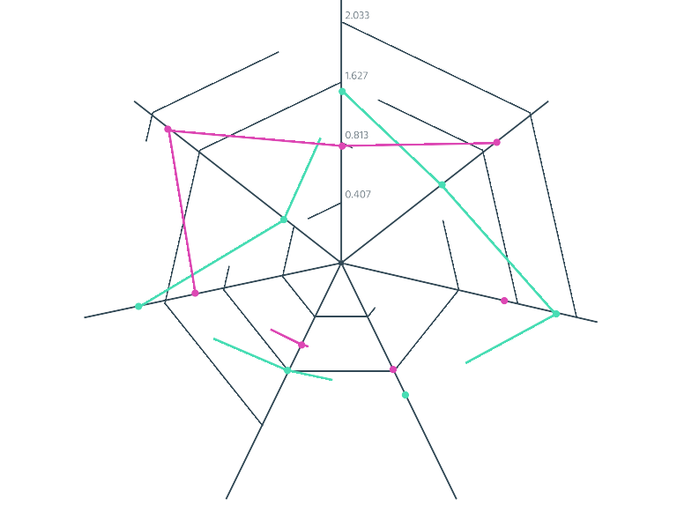

Technical Relevance

The TR (Technical Relevance) indicator is calculated by counting the number of prior art citations that a patent receives (forward citations). Citations are counted as citing families. Self-citations as well as subsidiary citations are not counted. Finally, counts are normalized by year, country of jurisdiction and main IPC/CPC (see page 10).

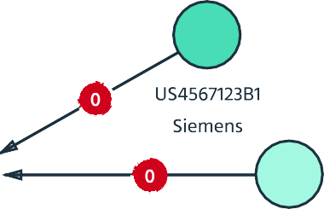
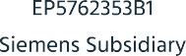





Siemens
EP7654321

/High/
A high TR value reflects a high technical relevance of a patent, since subsequent patents have to cite the patent as prior art. Patent citations are reviewed and verified by objective and qualified patent examiners. A high TR value thus identifies leading technologies of a particular market segment.

/Low/
A low TR value reflects a low technical relevance of a patent, since subsequent patents are not citing the patent as prior art. A low TR value reflects that a patent either protects a niche technology or a technology that is not of relevance to other market participants.

Market Coverage

The MC (Market Coverage) indicator is calculated by counting the number of countries the patent has been filed for (jurisdiction), weighted by the country’s GDP. Finally, counts are normalized by year, country of jurisdiction and main IPC/CPC (see page 10).

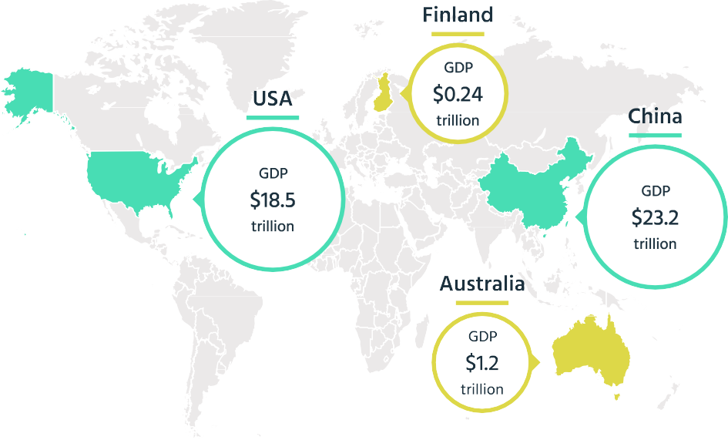


/High/
A high MC value reflects a global internationalization strategy and a wide legal market protection. Furthermore, a high MC value reflects a high perceived patent value for the applicant. Patent application and patent maintenance fees create considerable costs at each patent office. The more countries a patent has been filed for the higher the perceived international market potential for the patented invention.

/Low/
A low MC value reflects a local internationalization strategy and a narrow legal market protection. The less countries a patent has been filed for the lower the perceived international market potential for the patented invention.

Radicalness

The RA (Radicalness) indicator is calculated by counting the number of patent citations a patent has to cite as prior art (backward citations) taking into account whether a cited patent has cited frequently itself (cited backward citations). Finally, counts are normalized by year, country of jurisdiction and main IPC/CPC (see page 10).

/High/
A high RA value indicates a high degree of novelty in a certain technological area. The patent was filed in a so called “white space” where very little prior art existed.

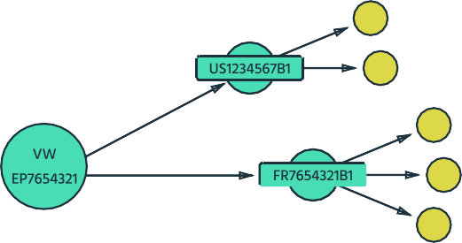
/Low/
A low RA value indicates a lower degree of novelty in a certain technological area. The patent was filed in a so called “patent thicket” where a dense web of patents already protected a certain technology.

Legal Breadth

The LB (Legal Breadth) indicator is calculated by counting the number of words used in the shortest independent claim. Adding more words to a patent claim decreases its scope of potential application and thus the legal breadth of a claim. Finally, counts are normalized by year, country of jurisdiction and main IPC/CPC (see page 10).

/High/
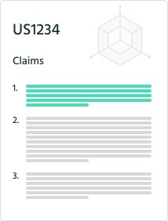
A high LB value (small number of words used in the shortest claim) indicates broad claims and thus a wide legal scope of the patented technology.

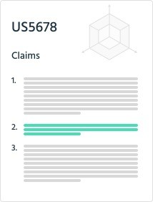
/Low/
A low LB value (high number of words used in the shortest claim) indicates narrow claims and thus a restricted legal scope of the patented technology.

Patent Scope

The SC (Scope) indicator is calculated by counting the number of distinct main IPC/CPC classes (4 digits) a patent has been classified to, by the examiner. Finally, counts are normalized by year, country of jurisdiction and main IPC/CPC (see page 10).

/High/


A high SC value reflects a wide technological applicability of the patent. Patent portfolios classified in several main IPC/CPC classes can be interpreted as cross-over technologies.

/Low/
A low SC value reflects a narrow technological applicability of the patent. Patent portfolios classified in a few main IPC/CPC classes can be interpreted as specific technology solutions.

Cooperation

The CO (Cooperation) indicator is calculated by counting the number of legally independent patent co- assignees. Subsidiary cooperation are not counted. Finally, counts are normalized by year, country of jurisdiction and main IPC/CPC (see page 10).

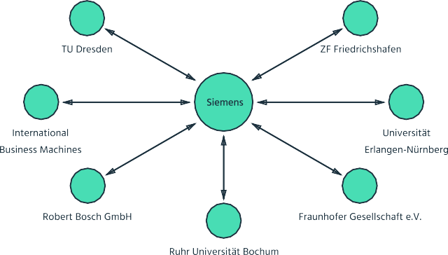
/Low/
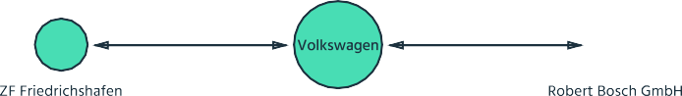
A low CO value reflects a tendency to develop technologies without cooperating with other companies but conducting research rather internally.

/High/
A high CO value reflects a tendency to develop technologies in cooperation with other companies. IPlytics makes use of corporate tree information to rule out subsidiary and parent company cooperation.

Team Size

The TE (Team Size) indicator is calculated by counting the number of inventors that are listed on a patent. Finally, counts are normalized by year, country of jurisdiction and main IPC/CPC (see page 10).

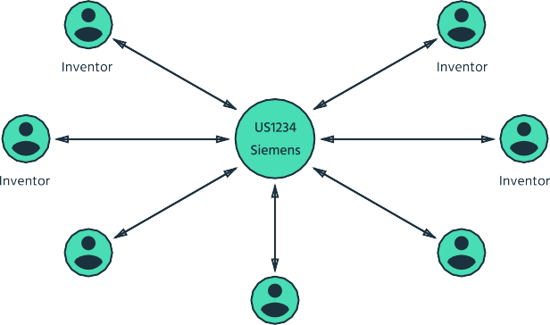
/High/
A high TE value reflects that the patent portfolio was developed by larger research groups. The indicator helps to benchmark research activities
e.g. in connection to R&D spending of other market players.

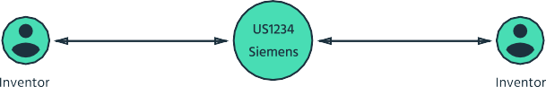
/Low/
A low TE value reflects that the patent portfolio was developed by smaller research groups.

Normalization

In order to provide comparability of different patent portfolios, all indicators are normalized by averages of patent control groups of the same patent office, same IPC/CPC class and the same publication year. A patent from 2010 filed in the US with the IPC/CPC H04W that e.g. receives 6 foreword citations is compared to the average forward citation counts of all US/2010/H04W patents. If the forward citation count is 6 and the average is 3 the indicator would be 2, meaning twice as high as average.

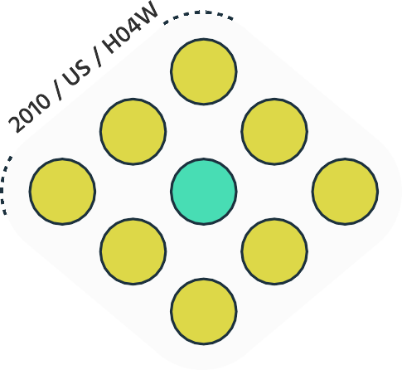

8
3
3
0
6
4
1
0
2


=


Normalized indicators allow comparing patent portfolios of different age, technological focus or country. All patent indicators are normalized by 1 and can thus be interpreted as follows:

Value >1 indicates a patent value above technology, country and year average

Value <1 indicates a patent value below technology, country and year average

